So, You Want to Tackle Media Literacy?

•What is Media Literacy?
The ability to access, analyze, evaluate, create, and communicate using a variety of objective forms, including, but not limited to, print, visual, audio, interactive, and digital texts.” (Illinois General Assembly, 2021)
•Analyzing and Evaluating Media Content
There are several ways to learn to analyze media, but here are 5 Key Questions from The Center for Media Literacy: (CML, 2022)
•Who created this message?
•What techniques are used to get my attention?
•How might other people understand this message differently?
•What values or lifestyles are represented or omitted from this message?
•Why is this message being sent?
•Media Consumption
News, real or fake, travels at breakneck speeds online, but the different age groups tend to use it in different ways. Some in the 70s-80s age group are not online at all and miss everything that does not make it into a newspaper or on television. Younger teens are unfamiliar with how to use a mouse. There is also a divide in what kind of news reaches different age ranges based on the apps they use or social media algorithms. (Kelly, 2021)
This leads to media bubbles. Algorithms try to predict what people want to see or interact with, and combined with the filters people can set on their own feeds, news media bubbles happen and everyone is not getting the same news. OR They're getting the same news but filtered or reported in separate ways. (GCFGlobal 2022)
In addition, local newspaper companies are shutting down, being bought out, or merging, causing "news deserts" where areas are experiencing only one or no news organizations reporting on local news which can lead to an uniformed public or biased news. (UNC, Hussman School of Journalism and Media, 2022)
•MISinformation VS DISinformation
- •MISinformation: incorrect or misleading information that is described as fact. It is often shared without the person realizing it isn't correct in an attempt to help or feel a part of a community. (Merriam-Webster. (n.d.).)
- •DISinformation: false information deliberately and often covertly spread in order to influence public opinion or obscure the truth. Often shared with the intent to sow distrust or for monetary or political gain. (Merriam-Webster. (n.d.).)
•Resources for Learning to Evaluate
Before teaching Media Literacy, you must know how to analyze and evaluate it yourself. The following bibliography has a wealth of information for evaluating media and teaching about media literacy.
•Sample Lesson Plans
PBS Station WQED created an excellent lesson plan that works for multiple ages on how to analyze media
https://microcredentials.digitalpromise.org/explore/analyzing-media
First Draft News has a great Google slide about differences and warnings to look out for between Disinformation and Misinformation
https://docs.google.com/presentation/d/1Yv-MSVFvl4yGTxYAcQIFiIGSPyPqkWwkaafO902BgEQ/edit?usp=sharing
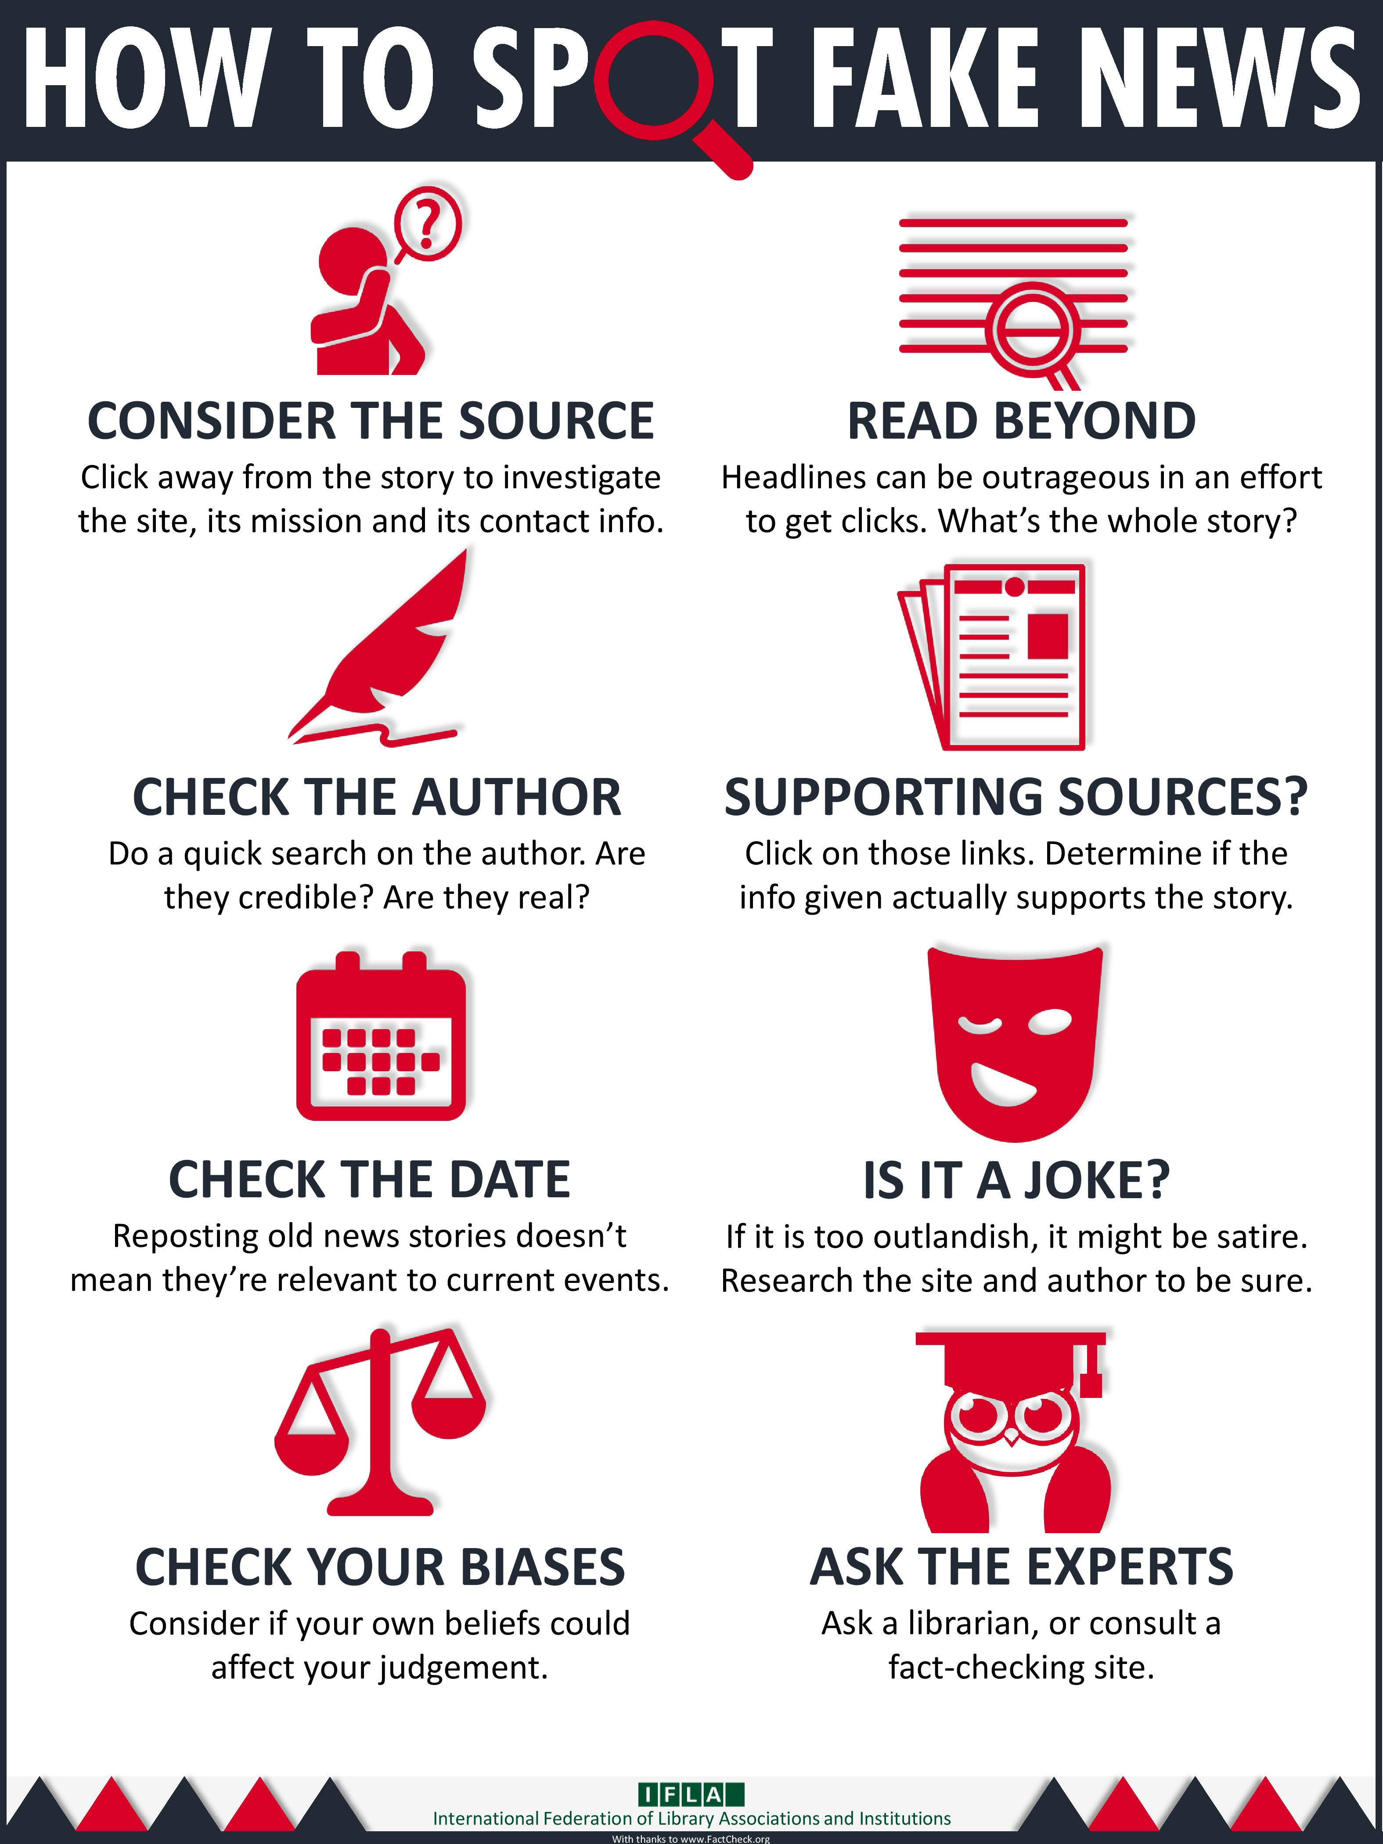

IFLA Infographic https://repository.ifla.org/handle/123456789/167

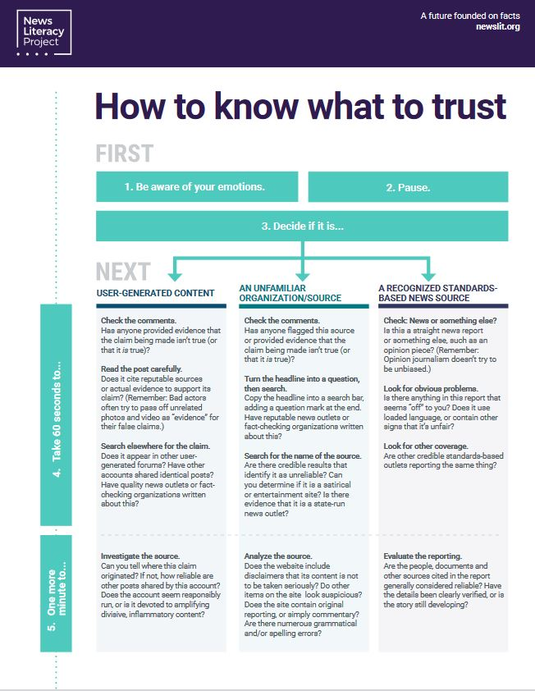
https://newslit.org/wp-content/uploads/2020/09/How-to-know-what-to-trust-DIGITAL_092320.pdf

Bibliography
•Sample, I. (2020, January 13). What are deepfakes – and how can you spot them? | Internet | The Guardian. The Guardian; www.theguardian.com. https://www.theguardian.com/technology/2020/jan/13/what-are-deepfakes-and-how-can-you-spot-them
•Groh, M. (2020, June 6). DeepFakes, Can You Spot Them? DeepFakes, Can You Spot Them?; detectfakes.media.mit.edu. https://detectfakes.media.mit.edu/
•Illinois General Assembly (2021) Illinois Compiled Statues https://www.ilga.gov/legislation/ilcs/fulltext.asp?DocName=010500050K27-20.08
•Center for Media Literacy (2022) MediaLit Kit https://www.medialit.org/cml-medialit-kit
•Eveleth, R. (2012, December 12). How fake images change our memory and behavior. BBC https://www.bbc.com/future/article/20121213-fake-pictures-make-real-memories
•Kelly, S. (2021, November 8) Parents of the social media generation are not OK. CNN Business https://www.cnn.com/2021/12/08/tech/social-media-parents/index.html?utm_source=pocket-newtab
•GCFGlobal (2022) How filter bubbles isolate you. GCFGlobal https://edu.gcfglobal.org/en/digital-media-literacy/how-filter-bubbles-isolate-you/1/
•University of North Carolina Chapel Hill, Hussman School of Journalism and Media (2022) Do You Live in a News Desert? https://www.usnewsdeserts.com/states/illinois/
•Merriam-Webster. (n.d.). Misinformation. In Merriam-Webster.com dictionary. Retrieved August 23, 2022, from https://www.merriam-webster.com/dictionary/misinformation
•Merriam-Webster. (n.d.). Disinformation. In Merriam-Webster.com dictionary. Retrieved August 23, 2022, from https://www.merriam-webster.com/dictionary/disinformation
•Gonchar, M and Engle, J. (2020, October 26) Should Media Literacy Be a Required Course in School? The New York Times, https://www.nytimes.com/2020/10/26/learning/should-media-literacy-be-a-required-course-in-school.html
•Inman, M. (2017, May 2) You’re Not Going to Believe what I’m About to Tell You. The Oatmeal, https://theoatmeal.com/comics/believe
•Hancock, P. (2021, July 12) Governor has signed 97 of more than 600 bills passed this year Capitol News Illinois https://www.capitolnewsillinois.com/NEWS/media-literacy-requirement-animal-products-ban-among-latest-53-bills-signed-by-pritzker
•New Literacy Project (2020, February 18) How to know what to trust: Seven steps, News Literacy Project https://newslit.org/updates/how-to-know-what-to-trust-seven-steps/
•Shodiya & Whatley (2021, November 11) Science Denial [audio podcast] Dopelabs Podcast https://www.dopelabspodcast.com/podcast-episodes/037-science-denial
•Wicks, A. (2021, May 28) How to Improve your Media Literacy. The University of North Carolina at Chapel Hill https://www.unc.edu/discover/how-to-improve-your-media-literacy-skills/
•Caulfield, M. (2022, June 2). Los Angeles Valley College Library: Information Evaluation: What is the SIFT Method? What Is the SIFT Method? - Information Evaluation - Los Angeles Valley College Library at Los Angeles Valley College; lib.lavc.edu. https://lib.lavc.edu/information-evaluation/siftmethod
•LibGuides: FAKE NEWS vs. REAL NEWS: How to Determine the Reliability of Sources: Tips for Evaluating News Stories. (2021, November 18). How to Determine the Reliability of Sources - LibGuides at Los Angeles Pierce College; library.piercecollege.edu. https://library.piercecollege.edu/c.php?g=598055&p=4140227
PBS Station WQED created an excellent lesson plan that works for multiple ages on how to analyze media
https://microcredentials.digitalpromise.org/explore/analyzing-media
https://illinois.pbslearningmedia.org/collection/newsandmedialiteracy/
First Draft News has a great Google slide about differences and warnings to look out for between Disinformation and Misinformation
https://docs.google.com/presentation/d/1Yv-MSVFvl4yGTxYAcQIFiIGSPyPqkWwkaafO902BgEQ/edit?usp=sharing

